Source Passages (Completed)

1 | 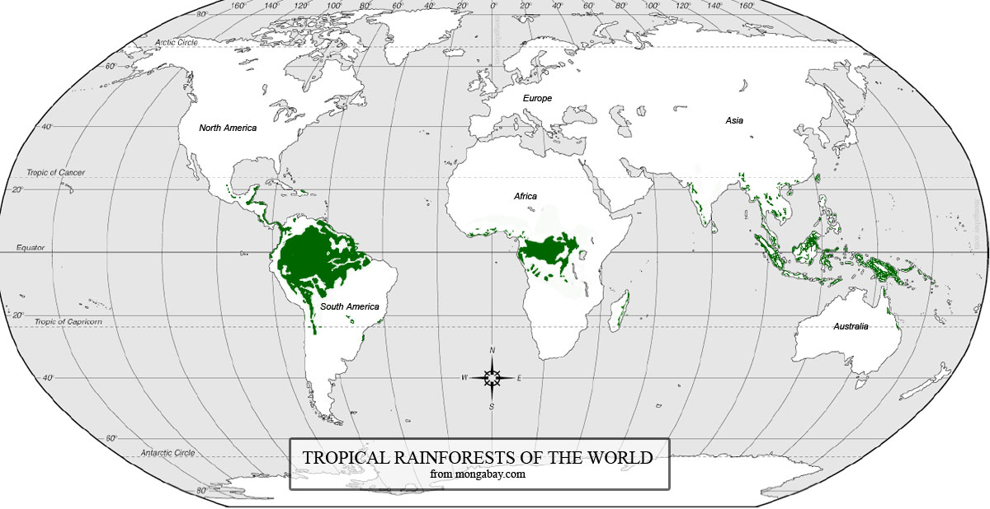  Web page  “Tropical Rainforests of the World”  No author, no date  http://kids.mongabay.com/elementary/002.html

2 | - An area of tropical forest the size of Britain is deforested every year. That is one million acres a week, or 100 acres a minute.  - In 1950, 30% of the earth was covered by tropical forest. By 1975, only 12 % was left.  - Today more than 40% of the world's original tropical forests have gone. Latin America has lost 37% of its original tropical forests, Asia 42% and Africa 52%.  - The world is now losing its tropical forest at the rate of 7% a year and the end of the tropical rainforests in sight.  Online periodical article  New Internationalist Magazine, issue 184  June 1988  https://newint.org/features/1988/06/05/facts/

3 | Forests are one of the most valuable ecosystems in the world, containing over 60% of the world's biodiversity. This biodiversity has multiple social and economic values, varying from the important ecological functions of forests in terms of soil and watershed protection to the economic value of the numerous products which can be extracted from the forest. For many indigenous and other forest-dependent people, forests are their livelihood. They provide them with edible and medicinal plants, bush meat, fruits, honey, shelter, firewood and many other goods, as well as with cultural and spiritual values. On a global scale, all forests play a crucial role in climate regulation and constitute one of the major carbon sinks on earth, their survival thus preventing an increase in the greenhouse effect.  Book Title: Trees: Propagation and Conservation  Authors: Ankita Varshney, Mohammad Anis  © Springer India 2014  Published in New Delhi  Pages: 1-2  Google Book

4 | The United States Cancer Institute has identified more than 2,000 tropical rainforest plants with the potential to fight cancer. And yet, as the forests come down, such plants - and the hopes they embody - are destroyed. Already about 40% of all drugs prescribed in the United States owe all, or much, of their potency to chemicals from wildlife - largely from the rainforest. Quinine, which acts against malaria, comes from the bark of a South American tree. The armadillo is helping us find a cure for leprosy. Sufferers from high blood pressure gain relief from the snakeroot plant from Indian forests. And the yam has given us the contraceptive pill.  Web article  Andy Gillett, 2015  “Tropical Rainforests and Medicine”  http://www.uefap.com

5 | Until now, there has been enough remote and underdeveloped land for small groups of people to follow their traditional ways of life without interference; and since such people rarely make any drastic change in their environment, their life is often life in the rain forests. The forest provides their food (wild vegetables, fruits and hunted animals) and their material culture (houses or shelters, boats, hunting equipment, twine, rope, poisons and medicines). There are reckoned to be over 4,000 plant species used by forest dwellers as food and medicine alone, many of which are local or endemic, known only to small groups whose knowledge of the forest is passed on orally, from generation to generation. Adapted to life in the forest, self-sufficient in it, using its products but never destroying their source, hunting forest animals but only according to need, such people both protect the forest and are protected by it.  Web article  Andy Gillett, 2014  “Tropical Rainforests and Indigenous people”  http://www.uefap.com

6 | Rainforests influence the carbon cycle (green plants take up carbon dioxide, which they convert to sugars by means of photosynthesis, a process during which oxygen is released into the air) and also have a profound effect on rainfall. The uneven surface of treetops causes air turbulence that increases the amount of water evaporating from the forest. This forms clouds that fall as rain. If forests disappear, less rain will fall, it will drain more quickly, and soil temperature will rise.  Web article  Andy Gillett, 2016  “Carbon Cycle”  http://www.uefap.com

7 | Most striking is the obvious lack of trees. With the population growth in the region, the amount of land under cultivation increases. The forests are then cut down to make way for more agricultural terraces. This lack of trees has led to many problems. The soil is now exposed during the dry season and this land is very vulnerable to water erosion during monsoon rains. Lack of tree cover has led to a more exposed soil, highly susceptible to wind erosion. The consequent depletion of the topsoil reduces soil fertility, causing great concern to the food producing farmers. Kanda is located on very steep slopes. The soil substrate is soapstone, a particularly porous stone mined commercially. The area is thus made more vulnerable to landslides. Tree roots help retain soil stability when waterlogged by heavy downpours. In hilly areas, tree roots help in the maintenance of a healthy watershed system. Nowadays, with forests gone, many springs stop running in the dry season. Without the drawing action of deep tree roots, the underground water table has dropped beyond reach. Floods downstream from valleys such as Kanda are said to result from the lack of tree cover in the Himalayan Hills. With Monsoon patterns changing, and torrential unseasonal downpours increasingly common, this problem worsens to often catastrophic consequences.  Web article  Andy Gillett, 2013  “Effects of Deforestation”  http://www.uefap.com

8 | Most of Bangladesh lies less than 10 metres above sea level. Over 90 million people live within this area. Floods in 1987 covered 40% of Bangladesh and in 1988 they covered 62%. In Bangladesh the 'normal floods' resulting from the 'usual' monsoon rainfall are considered a resource by farmers. Monsoon flooding is necessary for the maintenance of agriculture with floodwaters covering 30% of the land in a normal year. Yet in certain years they can experience disastrous flood events. Abnormal flooding occurs once every few years and is regarded as an undesirable and damaging phenomenon. All floods are not caused by the same factors. One possible cause is that forest clearance in the Himalayas is responsible. They say it removes large areas of trees, which takes an important water store away, so more water goes as surface runoff. When trees are present they act as a natural buffer against erosion and floods. Surface flow is slowed; rainwater infiltrates the soil by way of root channels; the leaf canopy protects the surface of the soil from the impact of large raindrops; and the root systems bind the soil particles. Forest clearance may be the cause of widespread soil erosion in areas like Nepal. Downstream from the Himalayas, uncontrolled runoff caused by deforestation in the catchment areas of the major rivers, and the increased silting of river channels as a result of soil erosion may have contributed to disastrous flooding in Bangladesh.  Web article  Andy Gillett, 2012  “Bangladesh”  http://www.uefap.com

